

Community Short Breaks February Half-Term Activities 2026
https://www.coventry.gov.uk/special-educational-needs-disabilities/short-breaks
Dear Parents and Carers
Community Short Breaks provide activities for children living in Coventry with diagnosed disabilities aged 5 – 17 years old.
The Booking Line for February Half Term Activities will be open from Monday 26th January 2026 (9:00am) until Friday 30th January 2026 (4:00pm) from 09.00am until 4.00pm.

Please call 024 76 975464 to book by phone (available Monday to Friday from 9:00am – 4:00pm).

Bookings can also be made online at www.coventry.gov.uk/bookashortbreak during this period.

Bookings either online or by telephone that are outside of the dates and times stated will not be processed.

Please note places in sessions are limited; you will be able to select one venue for your child or young person to attend across the week as part of your ‘activity’, you can also select one venue as a second option if the first choice is not available. If activities are not required, please select ‘not required’.

Sessions will be delivered for children and young people aged 5 – 11 years old or 12 -17 years old registered with Community Short Breaks unless stated otherwise. Please find this information below the named activity.

If your child or young person has never attended a Community Short Breaks activity, we will require a completed Short Breaks passport and DLA letter or supporting letter.
An induction visit is required prior to attending an activity this will be arranged by Development Officer. Please let us know at the point of booking if you require this information.

Please note we cannot support siblings in activities unless stated.
Please Read: Important information about activities and venues

Date | Activity | Venue
WEEK ONE
Monday  16th February 2026 | Lunar New Year – Year of The Horse  Crafts - decorate your own horseshoe.  (12 – 17 years old)  10:00am – 11:30am  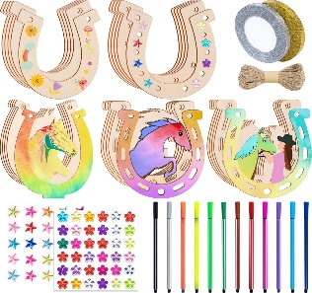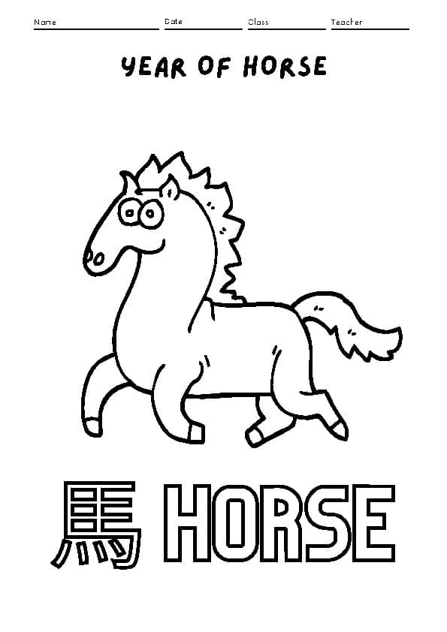  Mini-Pancake skewers with fruit toppings.   | Broad Park House  Logan Road  Coventry  CV2 1AG  *Activities can be amended to meet the interests of children.  *Please notify Development Officer in advance if your child has a food allergy or food intolerance.
Tuesday  17th February 2026 | Shrove Tuesday – Pancake Day  Decorating pancakes  with crafts and activities of interest.  (5 – 7 years old)  10:00am – 11:30am    Decorating red envelopes using glue and sparkles/stickers.  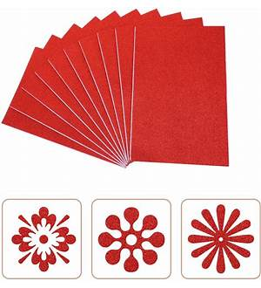  Lunar New Year – Year of the Horse  Game: Red envelope treasure hunt – find the chocolate gold coins  with crafts and activities of interest.  (8 – 11 years old)  12:00pm – 1:30pm  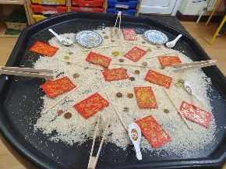  Decorate your own pancakes  Short Breaks Family Splash Pool  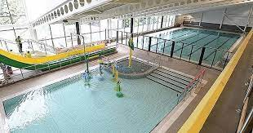  (5 – 11 years old)  2:00pm – 3:00pm | Broad Park House  Logan Road  Coventry  CV2 1AG  *Please notify Development Officer in advance if your child has a food allergy or food intolerance.  Broad Park House  Logan Road  Coventry  CV2 1AG  *Activities can be amended to meet the interests of children.  *Please notify Development Officer in advance if your child has a food allergy or food intolerance.  Centre AT7  12 Bell Green Road  Coventry  CV6 7GP  Please provide all children and adult’s names on the booking form attending Family Swim (5 – 11 years old).  Children must live within the family household.  Public Pool Rules: All children aged 8 and under must be accompanied by an adult.  Any child that cannot swim must be accompanied by an adult.  Parent/carers must stay at the pool side if not swimming with children.  £1.00 will be required for individual lockers.  If a child has a medical history, please notify the Short Breaks staff member/lifeguard on duty on arrival in case of an emergency.
Wednesday  18th February 2026 | Year of the horse – arts and crafts  (5 – 10 years old)  10:00am to 11:30am  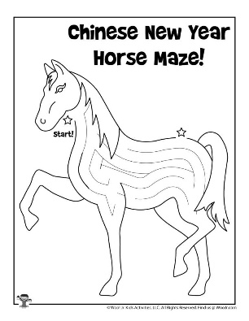    Chess and small board games  (11 – 17 years old)  12:00pm – 1:30pm  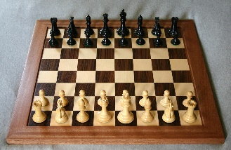  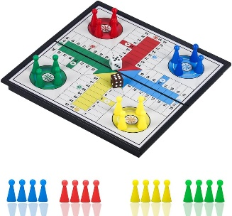 | Mosaic Hub  Jardine Cresent  Coventry  CV4-9PL  Mosaic Hub  Jardine Cresent  Coventry  CV4-9PL
Thursday  19th February 2026 | Line Sculptures and Art  with role-play and games.  (5 – 10 years old)  12:15pm – 1:45pm  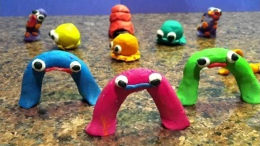    Popcorn making with arts and crafts with board games.  (11 – 17 years old)  2:15pm – 3:45pm    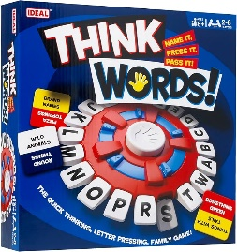 | Families For All  454 Foleshill Road  Foleshill  Coventry  CV6 5LB  Families For All  454 Foleshill Road  Foleshill  Coventry  CV6 5LB  *Please notify Development Officer in advance if your child has a food allergy or food intolerance.

